**Smart Parking**

**TEAM MEMBERS**

912221104018 - K.K.Hari Prakash

912221104016 - P.Gurudeep Swasanekar

912221104302 - J.Gnana Prakasha Martin

912221104006 - D.Aravind

912221104306 - P.Muneeswaran

**Phase-2 Innovation**

**Subject: Smart Parking**

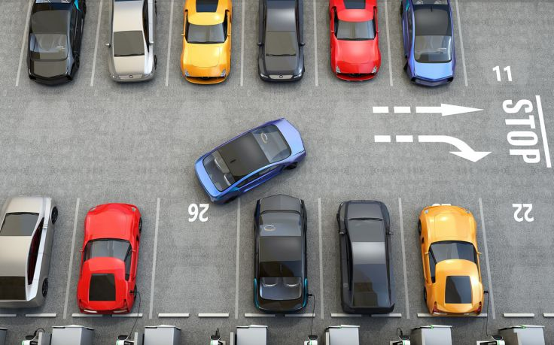

**Step 1: Define Clear Objectives**

Clear objectives are crucial when implementing a Smart Parking system. Define what you aim to achieve with this system. Objectives could include reducing traffic congestion, improving the parking experience for users, optimizing space utilization, and increasing revenue for the parking facility.

**Step 2: Assemble a Cross-Functional Team**

Form a team that brings together various skills and expertise. This team may include software developers, hardware engineers, urban planners, data analysts, and project managers. Collaboration among these experts is essential to ensure a well-rounded solution.

**Step 3: Conduct Market Research**

Thorough market research is necessary to understand the local parking landscape. Identify the existing problems, the preferences of users, and potential competitors in the area. This research will help you tailor your Smart Parking solution to the specific needs of your target market.

**Step 4: Refine and Prototype**

Develop a prototype or a minimum viable product (MVP) of your Smart Parking solution. This prototype should showcase the key features of your system, such as sensors, mobile apps, and payment methods. Testing and gathering feedback is vital during this phase.

**Step 5: Secure Funding**

Determine the financial resources required for your Smart Parking project. Funding sources could include government grants, private investors, or parking facility operators. Ensure that you have a clear budget and financial plan in place.

**Step 6: Develop the Smart Parking System**

Now, it's time to develop the Smart Parking system. This includes installing sensors in parking spaces, creating a mobile app for users, and setting up a central monitoring and control system. The development phase requires close collaboration among your cross-functional team.

**Step 7: Intellectual Property Protection**

Consider whether your Smart Parking system includes any novel technologies or processes that should be protected through patents or trademarks. Consult with legal experts to secure your intellectual property.

**Step 8: Test and Iterate**

Conduct thorough testing of your Smart Parking system. Ensure that the sensors accurately detect available parking spaces, the app functions smoothly, and payment processing is secure. Collect feedback from users and facility operators, and use this input to make necessary improvements.

**Step 9: Compliance and Regulations**

Ensure your Smart Parking system complies with all local regulations and standards, including privacy laws and safety requirements. Work closely with legal experts to ensure you meet all necessary criteria.

**Step 10: Marketing and Launch**

Develop a marketing strategy to introduce your Smart Parking system to the public. Create a launch plan that includes marketing materials, press releases, social media campaigns, and other promotional activities to attract users.

**Step 11: Monitor and Measure**

Once your Smart Parking system is operational, closely monitor its performance. Collect data on usage, revenue, and user satisfaction. Use key performance indicators (KPIs) to evaluate the system's impact on traffic congestion and parking facility revenue.

**Step 12: Feedback Loop**

Establish a feedback loop to continuously gather input from users and parking facility operators. This feedback will help identify areas for improvement and enhance the overall user experience.

**Step 13: Scale and Expand**

If your Smart Parking system proves successful in one location, consider opportunities to scale it to other areas or expand into new markets. This may involve partnerships with other cities or parking facility operators.

**Step 14: Continuous Innovation**

Innovation is an ongoing process. Encourage a culture of continuous improvement within your organization to stay ahead of evolving challenges and opportunities. Keep the Smart Parking system up-to-date with technological advancements.

**Conclusion:**

In summary, implementing a Smart Parking system involves a series of key steps, from defining objectives to continuous innovation. The aim is to enhance urban mobility, reduce congestion, and provide a better parking experience. Success requires thorough planning, testing, and adaptation to meet user needs and address urban challenges.